Lecturer’s name: N/A | Date: Day 3
Course: Math | Unit: Equivalent Forms of Fractions, Decimals, and Percents
Unit Duration: 10 days | Lesson Duration: 1 day
TEKS: 6.2D, 6,4G | Lesson Part 1
Topic: Converting Fractions and Decimals to Percentages

Lesson objectives:
1. SWBAT (Students will be able to) order rational numbers by comparing them to the benchmark of ½, 0.5, or 50% as an efficient strategy.
3. SWBAT solve real world problems involving comparing and ordering rational numbers

Essential Questions:
What strategies can be used to compare and order fractions, decimals and percents?
How can ordering and comparing help me become a fulfilled individual?

LYS Methodology

Be (Character/Values/Principles) - Educational, Financial, Vocational, Spiritual - How can ordering and comparing help me become a fulfilled individual?

Know (What resources are available to the student/ How can they use them) - Educational and Financial - Why is it important that we learn how to order and compare mathematically and how can we use that knowledge in our personal lives to achieve success however that may look like?

Do (Execute with Excellence) - Educational, Financial and Vocational - How can we use order and comparison to build discipline, set boundaries, and find purpose?

Resources (Include Technology):
Instructional Input - Asynchronous
AS: Anticipatory Set (Introduction)
- Students warm up for today’s lesson should be completing an FDP table such as this one
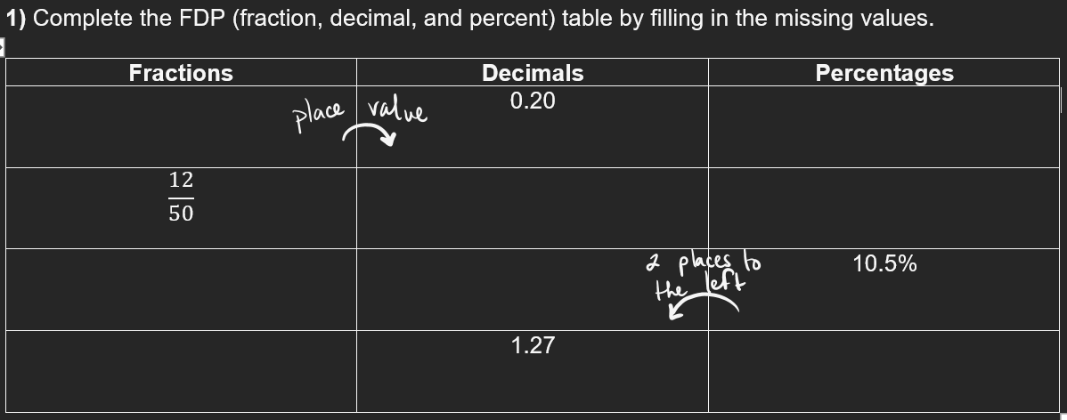

M: Modeling (I do)
- Introduce Key Point: To compare and order fractions, decimals and percents, I can think turn them all into the same form ( turn all values to fractions, decimals, or all into percents)
- Create 6 problems that include a mixture of fractions, decimals and percents asking students to compare with <, > or = . Most of the problems should be level 1 problems such as:
- Model Part 1: Teacher will model ONE problem by converting the values to the SAME form
- 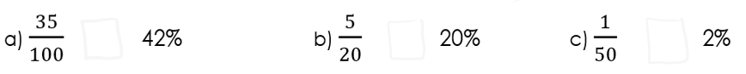
- Criteria for Success:
  - Turn all the value to the same format (either fractions, decimals or percents)

- Model Part 2: Model a real world problem
- 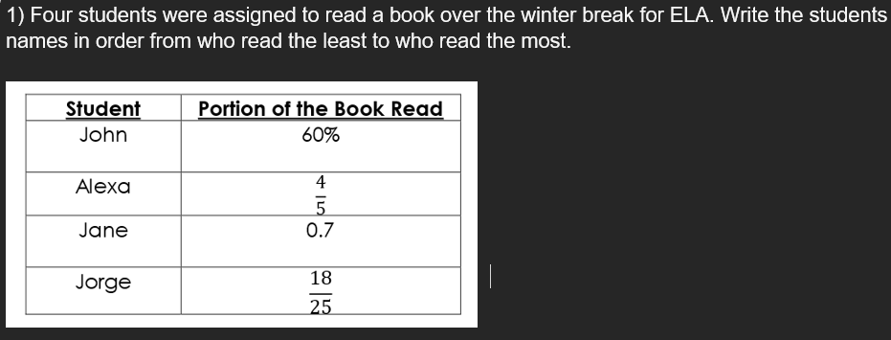
- Step 1: Convert all values to decimals
- Step 2: Compare the decimals from least to greatest
- Step 3: Write final answer with students’ NAMES, not values

GP: Guided Practice (We do)
- Teacher assign problems from page 163-164
- Online practice to get problems from - Compare and Order Problems

Instructional Input - Synchronous
AS: Anticipatory Set (Introduction)
- Students warm up for today’s lesson should be completing an FDP table such as this one


M: Modeling (I do)
- Introduce Key Point: To compare and order fractions, decimals and percents, I can think turn them all into the same form ( turn all values to fractions, decimals, or all into percents)
- Create 6 problems that include a mixture of fractions, decimals and percents asking students to compare with <, > or = . Most of the problems should be level 1 problems such as:
- Model Part 1: Teacher will model ONE problem by converting the values to the SAME form
- 
- Criteria for Success:
  - Turn all the value to the same format (either fractions, decimals or percents)

- Model Part 2: Model a real world problem
- 
- Step 1: Convert all values to decimals
- Step 2: Compare the decimals from least to greatest
- Step 3: Write final answer with students’ NAMES, not values

GP: Guided Practice (We do)
- Teacher assign problems from page 165
- Online practice to get problems from - Compare and Order Problems

Independent Practice/ Homework
- Students complete online game comparing fractions and decimals - Online Game Math 6

Lesson Close

Vocational
“Order and simplification are the first steps towards the mastery of a subject” - Thomas Mann

Humans are always striving for something, be it success, happiness, or to achieve a particular goal. Depending on a person’s individual way of living and their culture, those ambitions may differ. In order to achieve those ambitions, there must be order in one’s life along with a healthy hint of comparison. Comparison can provide for some a healthy sense of competitiveness that can propel chaos to convert itself into order.

Not only does comparing and ordering be helpful in mathematics, it can also help an individual create purpose, set boundaries and become more responsible to achieve his or her dreams and goals.

